ZH,
REPORT OF JOINT INVESTIGATION VISIT BY NOSDRA, SPDC, RIVERS STATE MINISTRY OF ENVIRONMENT AND NORKPO COMMUNITY REPRESENTATIVES AT 28” NKPOKU – BOMU PIPELINE @ NORKPO IN TAI L.G.A OF RIVERS STATE.
INTRODUCTION
Acting on your directives on the SPDC request sent in on 17th October 2017, a Joint Investigation Visit (JIV) was conducted at the 28’’ Nkpoku – Bomu Pipeline at Norkpo in Tai L.G.A of Rivers State on the 17th of October, 2017 at about 13:48Hrs. The investigation was completed successfully on the same day. This report provides details.
INCIDENT PARTICULARS: 2017_ 1949075
FACILITY AFFECTED: 28’’ NKPOKU-BOMU PIPELINE @ NORKPO IN TAI LGA RIVERS
STATE
DATE OF SPILL: 16/10/2017
DATE OF INSPECTION: 17/10/2017
CAUSE OF SPILL: SABOTAGE (CLAMP THEFT) (See Fig.1a & b)
QUANTITY OF CRUDE OIL SPILLED: NIL (Pipeline not tampered-with)
SPILL POINT COORDINATES: N 04^{O} 44’ 09.24’’
E 007^{O} 12’ 17.244”
NATURE OF IMPACT: No Impact (Non-Leaking Point)
INVESTIGATION TEAM:
- Koms Abam NOSDRA
- Momoh Ibrahim SPDC
- Chinedu Enechukwu SPDC
- Eigede Baba NPF - CID
- Ordu James RIVERS STATE MINISTRY OF ENVIRONMENT
- Emmanuel Nnenorde NORKPO COMMUNITY

OBSERVATIONS:
- On arrival at the Incident Site, the JIT was informed by SPDC Representatives that, on the 16th of October 2017, unknown persons excavated the TNP, with the intension of steeling the 28’’ X 14’’ PLIDCO SPLIT SLEEVE CLAMP previously installed by THE SPDC ASSET OWNER. That the suspected Clamp Thieves were apprehended by the Security Surveillance Team, but made away with half of the Clamp, while the Surveillance Team got hold of the remaining half. (See Fig. 1a). The Clamp Sleeve left behind was shown to the JIT.
- It was observed that, the supposedly excavated area was back-filled and compacted before the arrival of the JIT (See Fig. 1b), upon inquiry, the JIT was informed that, the Surveillance Team had to back-filled to guard against the thieves returning to tamper with the Pipeline(?)
- No Spill Impact was observed as at time of investigation. Upon exposure, the Clamp was actually missing but the white/black Polykene Tapes on the 28’’ Pipeline were still intact. (See Fig. 2a & b)
- The Incident (Non-Leaking Incident Point) occurred along SPDC ROW, traversed by light bushes and vegetation on either sides of the Pipeline Right-of-Way.
- The clamp was not replaced at the end of JIV. The SPDC Team said the work will be done on a later date.

RECOMMENDATIONS
- The Agency should be notified when repair work will be done on the line.

CONCLUSION
The JIV was successful. This report is subject to your steer and further directives.

Koms Abam
SES

_____________________________
18th October, 2017

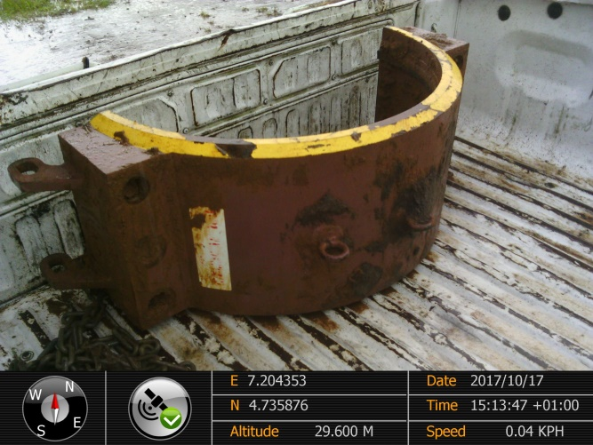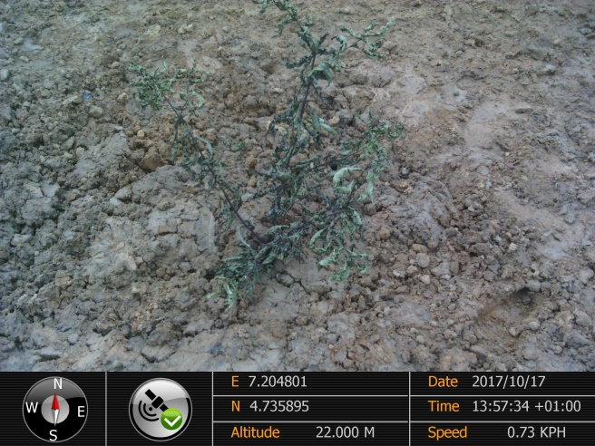
Fig. 1a PLIDCO Split Clamp Sleeve left behind Fig.1b Incident area back-filled before JIV

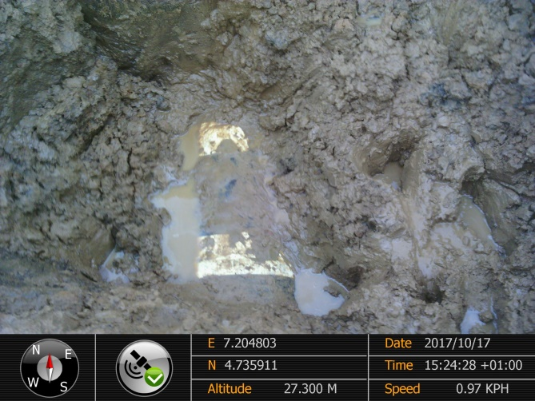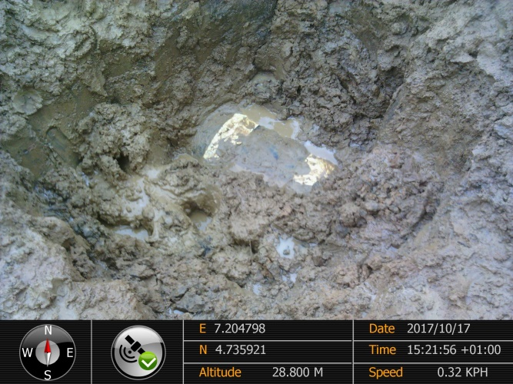
Figs. 2a & b 28’’ Pipeline showing original position of missing 28’’X14’’ PLIDCO Split Sleeve Clamp removed, exposing the Polykene Tapes which are still intact.

